

TERMS OF REFERENCE (TOR) - Consultancy Services (Matavolivoli Estate, Nadi)
Services: Environmental Impact Assessment (EIA), Traffic Impact Assessment (TIA), Environmental Management Plan (EMP) and Civil Works Design.
1.INTRODUCTION
The Public Rental Board (PRB), a commercial statutory authority established to provide affordable rental accommodation to low-income earners invites tenders from registered and qualified Environment, Traffic and Civil Works consultants to undertake the following services for the proposed new development project at the PRB Matavolivoli Estate in Nadi:
- Environmental Impact Assessment (EIA) with Environmental Management Plan (EMP)
- Traffic Impact Assessment (TIA) with Traffic Management Plan (TMP)
- Civil Works Design

The assessments and design services shall provide complete, reliable and professional documentation to support design enhancement, infrastructure planning, construction staging, regulatory compliance and long-term environmental management of the proposed development.
Eligible consultants are invited to submit tenders demonstrating relevant qualifications, technical capability and experience in delivering similar consultancy services.

Consultants are required to provide a detailed professional fee proposal for full assessment works and supply valuable expert information to guide environmental mitigation, identification of potential environmental, engineering design, construction planning and infrastructural constraints.

Locality Map – Matavolivoli Estate, Nadi (LOT 36 SO 7388)
Koroitamana Street
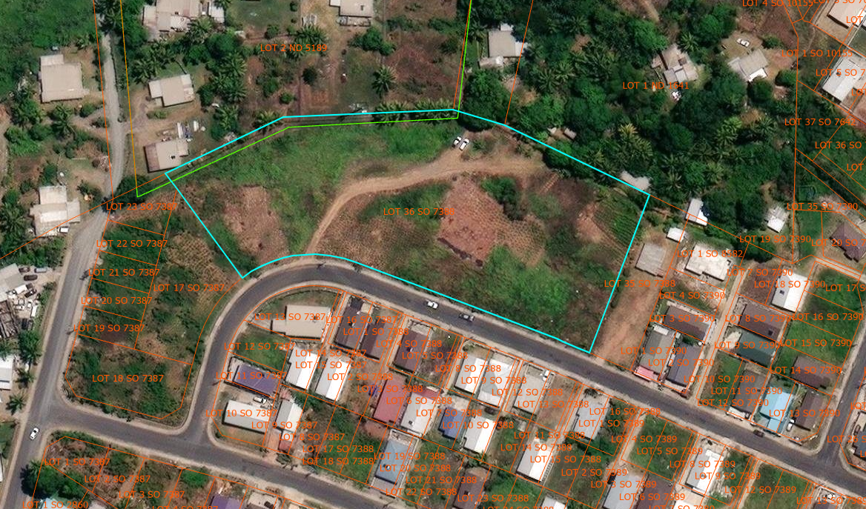
Vavabiau Street
Kasaqa Circle
PRB’s initiative is to undertake the Matavolivoli Estate development which consist of residential lots, facilities, amenities, services, sustainable energy growth & gray water harvesting.

Objective
Environment (TIA) & Traffic Impact Assessment (TIA)
Identify and assess potential environmental and traffic impacts associated with the proposed development and ensure that all risks to land, water, air quality, biodiversity, community wellbeing, and surrounding road networks are properly understood prior to the commencement of construction. The Environmental Impact Assessment (EIA) and Traffic Impact Assessment (TIA) shall recommend appropriate mitigation and management measures, identify environmental and traffic-related risks during both construction and operational phases and prepare Management Plans to guide regulatory compliance and project implementation.
Traffic volumes, road access, circulation, and network capacity shall be analysed to determine required safety improvements, road upgrades and supporting infrastructure requirements.

Civil Works Designs
The Civil Works Design Consultant shall undertake the planning and design of relevant civil infrastructure associated with the development including but not limited to site access roads, drainage systems, stormwater management, earthworks, retaining structures, utilities coordination and other supporting infrastructure necessary for the successful delivery of the project. The consultant shall provide complete and professional civil engineering documentation, drawings, specifications and recommendations to support efficient construction staging, infrastructure integration and long-term operational functionality.
Overall, the EIA, TIA, and Civil Works Design services will provide the necessary technical information and documentation to support PRB in securing approvals from the Department of Environment (DOE) and the Fiji Roads Authority (FRA) while informing the sustainable planning, design and implementation of the proposed development project.

2.SCOPE OF WORK
The Consultants is required to conduct comprehensive Environmental Impact Assessment (EIA) and Traffic Impact Assessment (TIA)/Civil Works Designs for the proposed development. The Scope of Work is divided into Environment Impact Assessment, Traffic Impact Assessment & Civil Works Design sections with each task explained for clarity and base on the attachment information documents.
- Geotech report
- Concepts Drawings
  - Environmental Impact Assessment
- The Consultant shall undertake a full Environmental Impact Assessment that includes reviewing the project description, layout, and proposed development activities, and conducting baseline environmental studies covering land, soil, water quality, drainage, vegetation, biodiversity, air quality, noise, and socio-economic conditions.
- The assessment must identify and evaluate all potential environmental impacts during site preparation, construction, operation, and decommissioning.
- As part of the EIA, the Consultant is required to carry out a comprehensive waste management assessment for greywater and blackwater, including analysis of wastewater generation, potential impacts on soil, groundwater, and surrounding ecosystems, and evaluation of both separate and combined treatment system options.
- The Consultant must determine the most suitable wastewater treatment technology based on site characteristics and provide a cost-benefit comparison and environmental performance assessment for each option.
- The EIA must also include stakeholder and community consultations in accordance with the Environment Management Act 2005 and EIA Regulations 2008, and provide practical mitigation, monitoring, and management measures within a complete Environmental Management Plan (EMP).
- The Consultant shall prepare and submit the Draft and Final EIA Reports with all relevant findings, technical data, and recommendations. The Consultant shall ensure that all assessments conducted under the Environmental Impact Assessment led to clear, conclusive, and technically justified recommendations. Based on the findings of the baseline studies, impact evaluations, and technical analyses, the Consultant must provide firm recommendations on the environmental feasibility of the proposed development, the required mitigation measures, and any necessary design or operational modifications. No part of the EIA shall contain open-ended, conditional, or inconclusive statements. All outcomes must be supported by data and professional judgment to enable PRB and regulatory authorities to make fully informed decisions without ambiguity.

  - Traffic Impact Assessment (TIA)
- The Consultant is to assess current road conditions, traffic volumes and safety issues around the site. This establishes a baseline for comparison.
- The Consultant is to carry out traffic surveys and prepare projected traffic volumes and trip generation based on the proposed development. This analysis is required to understand future traffic demand.
- The Consultant is to assess the impacts of increased traffic on surrounding roads and intersections. The assessment must highlight capacity, safety concerns and operational issues.
- The Consultant is to recommend improvements for site access, internal circulation, parking layout and external road upgrades. Recommendations must support safe traffic flow during construction and occupation.
- The Consultant is to prepare a Construction Traffic Management Plan. This must include measures to manage movement of vehicles, timing and safety controls during construction works.
- The Consultant is to produce draft and final TIA reports in accordance with FRA guidelines. Reports must provide PRB sufficient information for FRA approval.

DELIVERABLES
Consultant is responsible for delivering:
- Inception Report
- Draft EIA & TIA Reports for client's review
- Final EIA & TIA Reports
- Environmental Management Plan (EMP)
- Maps, surveys, technical data, and supporting documentation.

  - Civil Works Design

- Site Assessment and Data Review
The Consultant shall review all available project information including topographic surveys, geotechnical investigations (including draft geotechnical reports), environmental findings, traffic studies and concept master plans. The Consultant shall undertake site inspections and assess existing ground conditions, drainage patterns, soil conditions and surrounding infrastructure to inform detailed design development.

Concept and Detailed Civil Engineering Design
The Consultant shall develop concepts, and detailed civil works designs in accordance with applicable Fiji standards, statutory requirements and best engineering practice. This shall include:
- Site layout and earthworks planning
- Road design (internal roads, access roads, intersections, and pedestrian pathways)
- Pavement design for all road infrastructure
- Stormwater drainage systems including open drains, culverts, detention systems, and outfall structures.
- Flood mitigation and site water management strategies
- Retaining structures and slope stabilisation works where required.
- Water supply coordination and service connections (in liaison with relevant authorities)
- Sewerage and wastewater reticulation system design
- Utility servicing coordination (power, telecommunications, and other services)
- Greywater reuse and sustainable drainage integration in coordination with EIA findings

Infrastructure Integration and Coordination
The Consultant shall ensure full coordination between civil works design, environmental requirements and traffic recommendations. This includes alignment of road layouts with TIA findings, integration of drainage and wastewater systems with EIA/EMP requirements and ensuring infrastructure supports sustainable development outcomes.

Construction Planning and Staging
The Consultant shall provide engineering input into construction staging and sequencing, ensuring that civil works are designed to support efficient and safe construction implementation. This includes temporary access arrangements, erosion and sediment control measures and maintainability during construction phases.

Cost Estimation and Engineering Support
The Consultant shall prepare preliminary and detailed engineering cost estimates for all civil works components. The Consultant shall also provide technical advice to PRB on value engineering opportunities, cost optimisation and construction methodology options.

Drawings, Specifications and Documentation
The Consultant shall prepare complete engineering deliverables including:
- Concept design drawings
- Detailed civil engineering drawings suitable for construction
- Technical specifications and standards
- Bill of Quantities (BOQ)
- Design reports and supporting calculations
- Construction details and typical sections
All documentation shall be suitable for tendering, regulatory approvals and construction purposes.

Compliance and Approval Support
The Consultant shall ensure that all civil design works comply with relevant regulatory requirements and standards, including coordination with the Fiji Roads Authority (FRA), local authority requirements and integration with the Environmental Management Plan (EMP). The Consultant shall provide all necessary documentation and technical support required for approvals from relevant authorities.

Deliverables
The Consultant shall submit:
- Draft Civil Works Design Report for client's review
- Final Civil Works Design Report
- Approved engineering drawings and specifications
- BOQ and cost estimates
- Design certification and supporting technical documentation
All deliverables must be complete, technically justified, and suitable for implementation without ambiguity.

4. PAYMENT DRAWDOWN
  - Environmental Impact Assessment – Fee Proposal
No. | Description | Cost
1 | Mobilisation & Inception Report  Project commencement, review of available data, site visit, methodology confirmation, detailed work program, and submission of Inception Report.
2 | Completion of Baseline Environmental Studies  Completion of baseline data collection covering land, soil, water quality, drainage, vegetation, biodiversity, air quality, noise, and socio-economic conditions.
3 | Submission of Draft EIA Report  Identification and evaluation of environmental impacts across all project phases; including greywater and blackwater assessment, wastewater generation analysis, and evaluation of treatment system options.
Technology Assessment & Draft EIA Report
Determination of preferred wastewater treatment solution, cost-benefit analysis, environmental performance comparison, and submission of Draft EIA Report including preliminary EMP.
4 | Stakeholder & Community Consultations Completed  Conduct stakeholder and community consultations in accordance with Environment Management Act 2005 and EIA Regulations 2008; incorporation of feedback and preparation of final Environmental Management Plan (EMP
5 | Submission of Final EIA Report & Final EMP  Submission of final consolidated EIA report with conclusive findings, technical justification, mitigation measures, and regulatory compliance documentation.
6 | Presentation to Client and/or Regulatory Authorities (if required)  Support PRB during review process with the Department of Environment, respond to comments, Covers final presentation, clarifications, handover of all digital and hardcopy documents.
Total Cost (VIP)

  - Traffic Impact Assessment – Fee Proposal
No. | Description | Cost
1 | Mobilisation & Inception Report  Project commencement, review of available drawings and site layout, methodology confirmation, traffic survey planning, and submission of Inception Report.
2 | Existing Conditions Assessment  Assessment of current road conditions, traffic volumes, safety issues, and establishment of baseline traffic conditions around the site.
3 | Traffic Surveys & Data Collection  Execution of traffic counts, surveys, and data collection to determine existing traffic patterns and movements.
4 | Traffic Modelling & Impact Analysis  Preparation of projected traffic volumes, trip generation estimates, and assessment of traffic impacts on surrounding roads and intersections including capacity and safety analysis.
5 | Concept Design Recommendations  Development of recommendations for site access, internal circulation, parking layout, intersection improvements, and external road upgrades.
6 | Construction Traffic Management Plan (CTMP)  Preparation of Construction Traffic Management Plan including vehicle movement control, staging, timing, and safety measures during construction phase.
7 | Draft TIA Report Submission  Submission of Draft Traffic Impact Assessment report in accordance with Fiji Roads Authority (FRA) guidelines for review.
8 | Final TIA Report & Approval Support  Submission of final report incorporating FRA/principal comments and provision of technical support until approval is obtained.
Total Cost (VIP)

  - Civil Works Design
No. | Description | Cost
1 | Mobilisation & Inception Report  Project commencement, review of available data (topographic survey, geotechnical information, EIA/TIA findings, concept master plan), site reconnaissance, design methodology, and submission of Inception Report and work program.
2 | Site Assessment & Data Review Completion  Completion of detailed site assessment including drainage patterns, soil conditions, existing infrastructure review, and engineering constraints identification to support design development.
3 | Concept Civil Design Submission  Preparation and submission of concept civil works design including preliminary site layout, road alignments, drainage concept, earthworks strategy, and initial infrastructure planning.
4 | Detailed Civil Engineering Design (30–60% Design Stage)  Development of detailed design for roads, drainage systems, earthworks, retaining structures, water supply, sewerage, and utility coordination including integration with EIA/TIA outcomes.
5 | Infrastructure Coordination & Construction Planning  Finalisation of design coordination across disciplines including EIA/EMP and TIA requirements, construction staging plan, erosion/sediment control measures and temporary works considerations.
6 | Cost Estimation & Value Engineering Submission  Submission of detailed engineering cost estimates, BOQ, value engineering options, and construction methodology recommendations.
7 | Draft Civil Works Design Report Submission  Submission of complete draft civil works design report including drawings, specifications, calculations and engineering documentation for client review.
8 | Final Civil Works Design Submission & Authority Support  Submission of final approved design package including IFC drawings, specifications, BOQ and reports, plus support for approvals with Fiji Roads Authority (FRA) and other authorities until acceptance.
9 | Final Certification & Handover Documentation  Final design certification, incorporation of review comments, and submission of complete tender-ready documentation for construction implementation.
Total Cost (VIP)

Tender submission shall include but not limited to the following:
- Consultant/ individual profiles
- Company Registration & TIN Letter
- Certificate of Exemption
- Past work Experience
- Human Resources break-down
- Liability Insurance
- OHS certification
- Timeline
- Assumptions
- Limitations
- Fees and charges

5. TENDER REQUIREMENTS
- EIA consultant must be accredited under the Fiji EIA Consultants Register.
- TIA consultant must be a qualified Traffic/Transport Engineer or Planner.
- A copy of their membership certification shall be attached with the tender submission.
- Demonstrated experience in EIA/TIA for similar projects.
- Civil Engineer must be a registered member of the Fiji Institute of Engineers (FIE)
- The tender submitted shall not exclude any items listed above (Please indicate clearly if required items are excluded in the fee proposal).

Tender submission is to be marked: “Tender ##/26 – Matavolivoli Estate Consultancy Services - Mention Service to undertake EIA/TIA/Civil Works Design” and addressed to:
The General Manager
Public Rental Board
PO Box 5275
Raiwaqa.

All submission will be accepted and shall be uploaded to the PRB website www.prb.com.fj no later than 4.00pm on Friday 26th June 2026.

- PRB reserves the right to reject any tender. The lowest or any other offer shall not necessarily be accepted. Late tender submission will be disqualified.
- For further enquiries, please contact Rupeni Rabici on mobile (679) 9921860 or email tenders@prb.com.fj


TENDER #/ 25
Consultancy Services
Public Rental Board (PRB), a Commercial Statutory Authority established to provide affordable rental flats to low-income earners invites tenders from the qualified and registered Civil Engineering Firms, Environmental & Traffic Consultants and registered Land Surveyors to provide professional services for our proposed development sites across multiple locations.
Project Locations and consultancy services required as per site
- Jittu Estate (Suva) – Environmental Impact Assessment/ Management Plan, Traffic Impact Assessment/Management Plan, Peripheral Survey, Subdivision Survey & Civil Work Design.
- Mead Road Estate (Suva) - Environmental Impact Assessment/ Management Plan, Traffic Impact Assessment/Management Plan.
- Raiwaqa Ex 4 Storey Estate (Suva) - Environmental Impact Assessment/ Management Plan, Traffic Impact Assessment/Management Plan, & Civil Work Design,
- Matavolivoli Estate (Nadi) - Environmental Impact Assessment/ Management Plan, Traffic Impact Assessment/Management Plan, Civil Work Design.
- Vunimoli Estate (Labasa) - Environmental Impact Assessment/ Management Plan, Traffic Impact Assessment/Management Plan, Civil Work Design, Geotechnical Investigation
- Ex Sewer (Suva) – Civil Work Design, Peripheral Survey, Subdivision Survey, Traffic Management Plan.

Terms of Reference outlining overall works are available on the PRB tender portal www.prb.com.fj .

Tenders are to be marked “Consultancy Services” and addressed to:
The General Manager
Public Rental Board
PO Box 5275
Raiwaqa.

and all submissions are to be uploaded onto the online tender portal no later than 4.00pm on Friday 26th June 2026.
Lowest or any other offer will not necessarily be considered. PRB reserves the right to reject any tender. Late submissions will not be considered.

Contact person is Rupeni Rabici on mobile (679) 9921860 or email at tenders@prb.com.fj.

